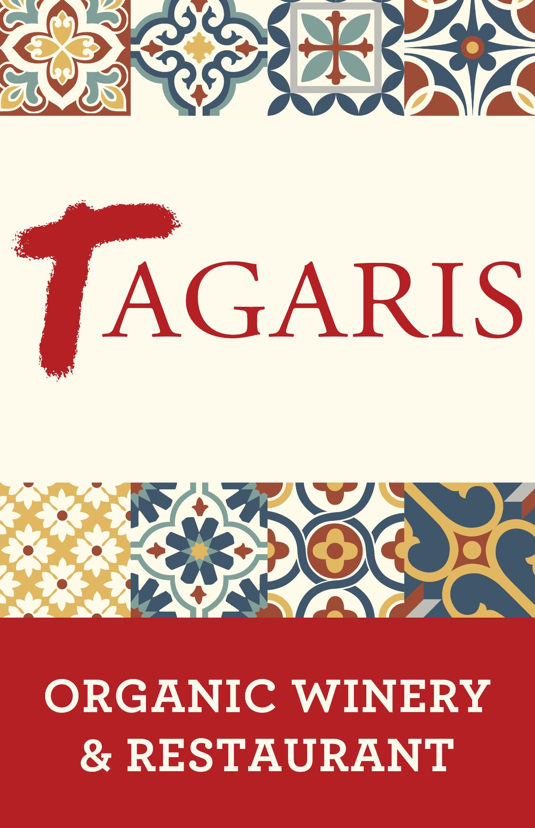
3 for $35 Menu
Tuesday & Wednesday
Starter
Choose one
SPRING GREENS SALAD
Spring Greens, Red Onions, Grape Tomatoes, Sherry Vinaigrette
CLASSIC CAESAR SALAD
Chopped Romaine, House Caesar, Shaved Parmesan
SOUP OF THE DAY
Ask your server for details

Entrée
Choose one
MANILLA CLAMS WITH LINGUINI
Tarragon, Chives, Eliseo Silva Chardonay, Shallots, Garlic, Butter, Lemon Juice, Grilled Crostini
TAGARIS GYRO
Cucumber, Grape Tomatoes, Red Onion, Barrel-Aged Feta, Tzatziki,
Meat Choice: Lamb and Pork Sausage, or Roasted Chicken
Served with choice of Chips or Frites
EMPANADAS DUO
Lamb & Pork, Red Onions, Roasted Tomatoes, Feta, Aji Verde Salsa
Pork Chorizo, Potatoes, Mozzarella, Aji Verde Salsa
HAVARTI & ROASTED RED PEPPER BURGER
House Made Chorizo Patty, Shredded Romaine, Caramelized Onion Aioli, Stone Ground Artisan Bun
Served with choice of Chips or Frites

Dessert
Choose one
CHOCOLATE BOMB
Flourless Chocolate Cake, House Made Espresso Ice Cream, Red Wine Reduction Sauce
STRAWBERRY LAVENDER FLATBREAD
House Made Crust, Streusel, House Made Vanilla Ice Cream
We politely decline any modifications.


