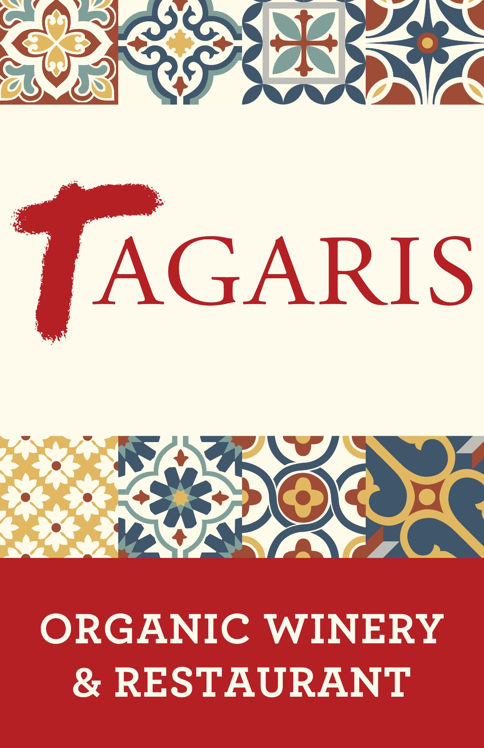
3 for $35 Menu
Tuesday & Wednesday
Starter
Choose one
GREEK SALAD
Whipped Feta, Cucumbers, Grape Tomatoes, Fennel, Kalamata Olives, Sherry Vinaigrette
CLASSIC CAESAR SALAD
Chopped Romaine, House Caesar, Shaved Parmesan
SOUP OF THE DAY
Ask your server for details
Entrée
Choose one
LINGUINI DE ALBONDIGAS
Pork & Lamb Meatballs, House Made Harissa, Basil Pesto, Fresh Burrata, Grilled Crostini
TAGARIS GYRO
Cucumber, Grape Tomatoes, Red Onion, Barrel-Aged Feta, Tzatziki,
Meat Choice: Lamb and Pork Sausage, or Roasted Chicken
Served with choice of Chips or Frites
ITALIAN SANDWICH
Grilled Aged Salami, Spicy Capicola, Heirloom Tomatoes, Shredded Romaine, Aged White Cheddar, Garlic Parmesan Aioli, Sherry Vinaigrette, Toasted Baguette – Served with choice of Chips or Frites
BLT BURGER
House Made Chorizo Patty, Applewood Smoked Bacon, Heirloom Tomatoes, Red Onion, Havarti Cheese, Spicy Market Tomato Jam, Garlic Parmesan Aioli, Stone Ground Artisan Bun
Served with choice of Chips or Frites
Dessert
Choose one
CHOCOLATE BOMB
Flourless Chocolate Cake, House Made Espresso Ice Cream, Red Wine Reduction Sauce
BROWN SUGAR AND PEACH FLATBREAD
House Made Crust, Streusel, House Made Vanilla Ice Cream
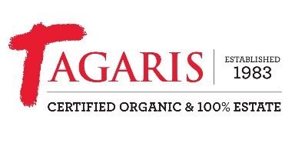
We politely decline any modifications.

